Solid Phase DNA Solution to the Hamiltonian Path Problem
N. Morimoto, M.Arita and A.Suyama
presented at 3rd Workshop on DNA computing, DIMACS Series in Discrete Math. and Theor. Computer Sci., Amer. Math. Soc.
June. 23 -- 25, 1997
Abstract
A solid-phase method for solving the Hailtonian path problem(HPP) employs only fast and simple DNA operations amenable to full automation. Single-stranded DNA molecules representing paths with no city visited twice are synthesized city-by-city from the start city on the surface for solid support. .
Methods
- Single-stranded DNA oligomer representing the sart city was 40 bases long : the 5’ end part of 25 bases long called a root sequence(RS) and the 3’ end part of 15 based long specifing the start city(v0) .

- Single-stranded DNA olligomers representing other cities than the start city were also a 40-base oligomer composed of two parts but with a slightly different structure : the 5’ end part was 15 based long and used to specify cith (vi) and the 3’ end part was a common sequence of 25 bases long called a tail sequence(TS).

- ASC : performs the attachment of the start city olligomer to a solid support.
- EXT : extends path strands on a solid spport by a city.(fig. 3)
- CAP : covers the 3’ end of path strands on a solid support with an unreactive group to prohibit further extension of the paths.
- RMVDC : removes path strands with a looping path. (fig. 4)
- DEBLK : removes the unreactive group to allow further extension of path strands. (fig. 4)
- repeat steps 2 ~ 7 (n-1) times, n = the number of citys

Restriciton enzyme：
- The RS part at the root of a path strand has the recognition sequence of an EcoRI restriction enzyme.A path strand with the duplication is therefore removed from a solid support by EcoRI digestion.
- The TS part at the 3’ end of a path strand has the recognition sequence of a BamHI restriction enzyme. The 3’ end of a path strand is thus activated to the next path extension by cutting the TS part off with BamHI

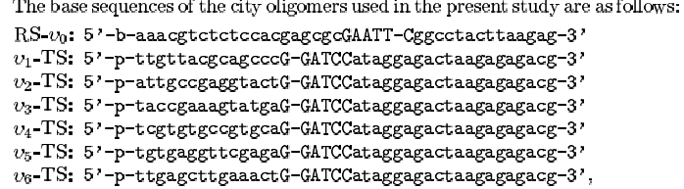

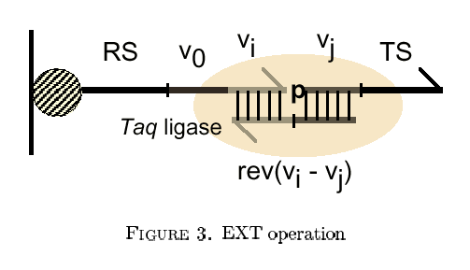
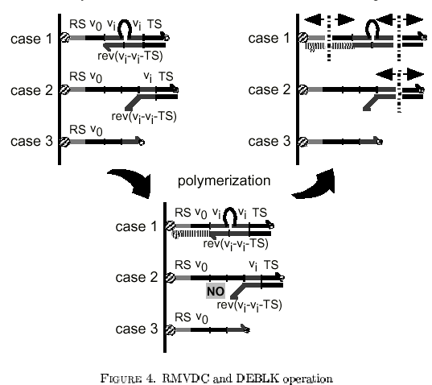
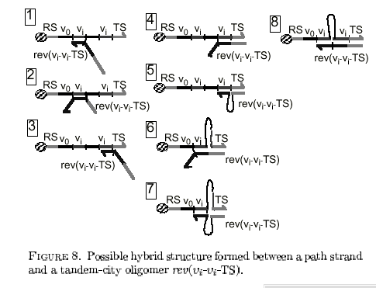
Created by : Hung-Yuan Wang
Date : Sep 6, 2001

